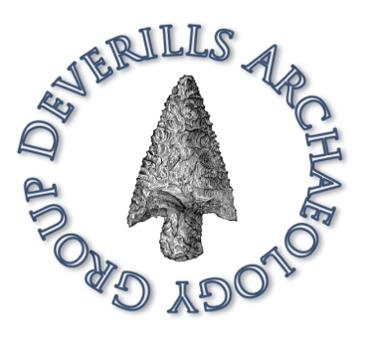
Deverills Archaeology Group

Home

Welcome to the Deverills Archaeology Group (DAG) website. DAG is a community archaeology group investigating the wonderfully rich archaeology of the Upper Deverill valley in SW Wiltshire, England.
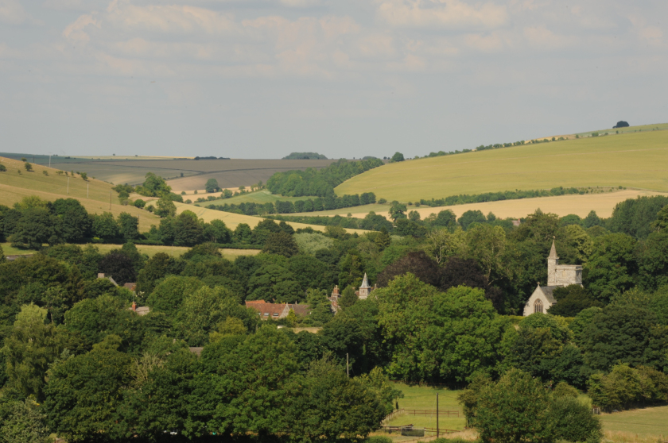

Photo: Mike Stanley

If you would like to receive emails from us about our activities please subscribe by clicking on this link.

FOLLOW BLOG VIA EMAIL

