Blog

The View from the Trench: DAG excavation - August 2018

Sally Jones shares her experience of her first archaeological excavation, undertaken by the Deverills Archaeology Group in August 2018.

…Day One
The warm August morning saw nineteen people gathered in a garden in the Deverill Valley: professional archaeologists, experienced amateurs, talented enthusiasts and a few, like me, complete archaeological novices. All were united in a common motivation to understand the people who preceded us through this special space, leaving an imprint, however slight, of their daily lives, experiences and histories. Over the next 10 days the professionals from Historic England would coach, encourage and lead us through all the stages of an archaeological excavation.
The garden was near the site of an historically significant, large Romano British Villa, discovered 3 years ago. Earlier in 2018, geophysical surveys of the garden area had revealed a possible enclosure defined by a perimeter ditch, together with a medium sized structure/building on the SE edge.
The enclosure exhibited rounded corners, which hinted, tantalizing, of Roman origins and a possible connection to the Villa.
Our task was to determine if excavation could support the Roman connection and, if not, what else lay hidden beneath these grassy acres that would further our knowledge of the history of the Deverill Valley.
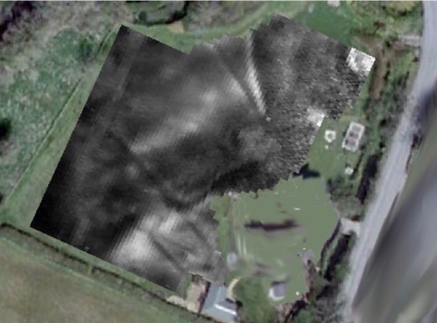
Geophysical Survey
Three trenches were mapped. HE brought out our assault tools: mattocks, spades, shovels, trowels, wheelbarrows and an improbable number of yellow buckets. For the uninitiated, the difference between a mattock and pickaxe was not immediately obvious, until practical employment revealed the distinct advantages of the flat edge.
Turves, topsoil and an additional stony level were removed. Our mentors pronounced themselves satisfied, and cautiously suggested the possible appearance of Roman archaeology, by way of ditches, in all 3 trenches.
A small number of ‘finds’ showed examples of Medieval, Post-Medieval and, yes, Roman pottery sherds, together with some rather intimidating animal teeth.
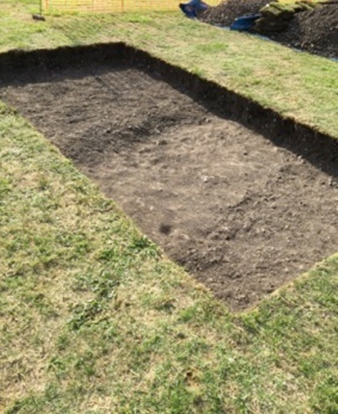
Possible Roman Ditch

…Day Two
Rain threatened from the outset and only a little over an hour’s digging was achieved. Now we were to witness the frustration of the seasoned archaeologist, as, even in this short space of time, one of the hoped-for Roman ditches ‘disappeared’ under further trowelling.
Rain called a halt to outside work and we retired indoors for a teach-in on finds identification.
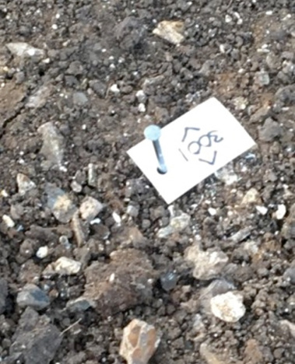
Marking a Find

…Finds Identification
The experts in pottery and flint identification gave us the most interesting insight into their respective worlds.
Roman pottery was mostly wheel turned (we learnt to look for the ripple effect) and well made; it was seldom glazed. ‘Glaze’ soon became a harbinger of dashed expectations. Many a hopeful sherd, on cleaning, revealed itself to be tainted with the despondent green glaze characteristic of medieval pottery and, like true Romano British enthusiasts, we soon cultivated the requisite dismissive shrug, so excellently demonstrated by our mentors, in the presence of green glaze.
We were educated in spotting the cuts and whirls of debitage, the offcuts occurring in the manufacture of flint tools. As the week wore on, it became clear that our earlier Valley settlers had left us much debitage, or by–product of their labours, but thoughtlessly failed to discard a single cutting tool or arrow head to excite us further.

…Days Three, Four and Five and the trenches started to disclose their own special stories and round-up talks at the close of each day’s digging were beginning to reveal serious trench envy amongst some of the excavation participants.
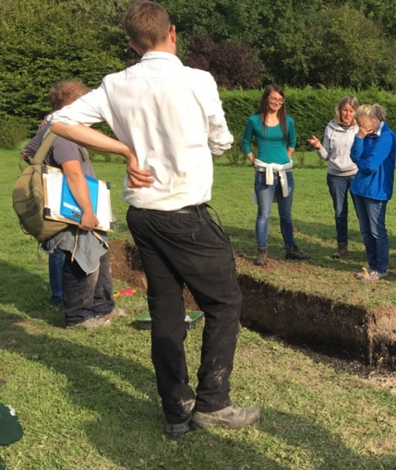
Trench Envy, A Bad Case
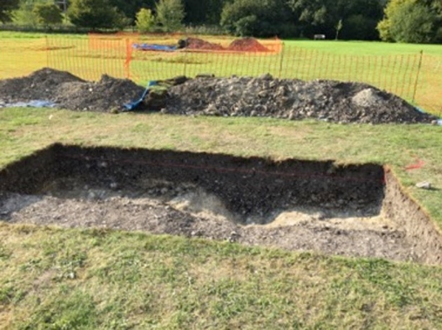
Trench B’s Roman Ditch, evidenced by exclusively Roman Pottery Finds
Trench A was definitely failing to deliver, having revealed two ‘Red Herrings’ by way of Victorian drainage ditches, evidenced by a small section of clay tobacco pipe. With more hope than expectation, another possible feature was being offered up to the mattock in this trench.
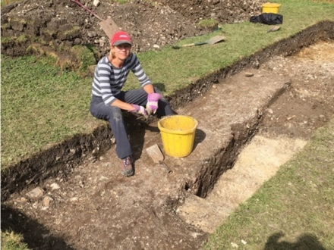
Hopeful in Trench A
Trench C, however, was unveiling an interesting puzzle, with the beginnings of a possible Roman track, a Roman ditch and another decidedly peculiar parallel ditch, the depth and width of which seemed to be growing by the hour.
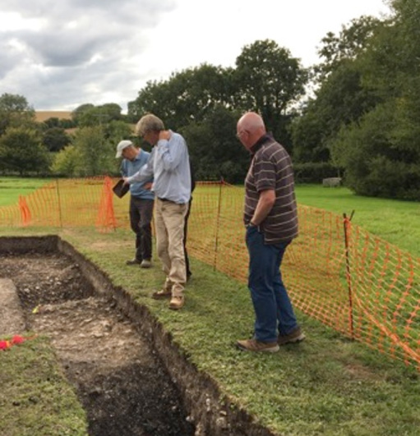
Puzzling over Trench C

…The Technicals
HE’s education programme was designed not simply to enlighten us in the finer points of trowelling. With great patience from the professionals, the technical aspects of excavation were not permitted to slip through our fingers.
We looked at stratigraphy, the layering of deposits in our trenches and became very familiar with the particularly unyielding alluvial clay deposits typical of this area.
Context sheets for ‘deposits’ and ‘cuts’ were produced and we were soon rolling soil samples between our fingers and identifying colours courtesy of the Munsell soil guide. Finds from each context were bagged and labelled with their respective site reference and context number.
Then came the photography (light relief):
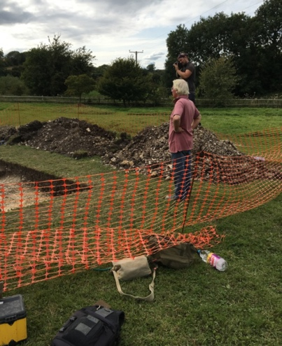
…followed by the complexities (to the novice) of section drawings and measurements; building up an accurate and annotated cross sectional map of each trench. A Harris Matrix was drawn to create a flow chart recording the sequence in which the levels and features of the trench occurred.
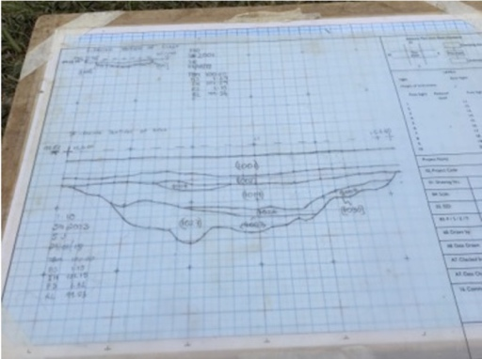
Section Drawing of the Trench A
Having established that the cry of “Dumpy Level !” was not an order for me to start leveling my trench, we moved on to general surveying techniques.

…The Tours
During the 10-day duration of the dig, HE engaged with local residents and DAG members through several conducted tours of the excavation. One of these tours was fortunate enough to coincide with the appearance of an Environmental Archaeologist in Trench C.
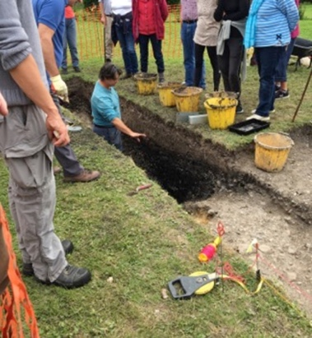
Taking Soil Samples
By studying the tiny things, like soil, pollen and snails the environmental archaeologist hopes to discover the nature and occupation of the site. Snails will reveal whether the site once had long grass, short grass or woodland. Pollen will tell what cereals were grown, chaff will tell whether the site was producing and growing, or buying in and processing. We can learn what type of foods were prepared and eaten.
…Day 5 and 6 and back in the trenches a more consistent image of the site was beginning to evolve. Trench A and B confirmed the existence of the boundary ditches surrounding the main enclosure and the small southern building/enclosure. No evidence was found of the foundations for this building, but in all likelihood it was wooden in nature, possibly a barn.
Trench C was now the decided hero of the week. The excavators were uncovering a blushingly embarrassing wealth of Roman pottery. Utilitarian in nature, the sherds were suggesting cookware and everyday utensils. A hypothesis was beginning to emerge.
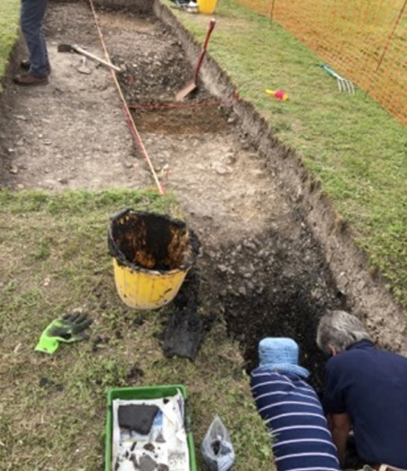
Squeezing into Trench C
In the above photograph, it is also possible to see the cobbled surface of a raised Roman track heading off towards the Villa.
A fourth trench was opened in the middle of the enclosure, attempting to explain the area of high resistivity visible in the geophysics; was it a cobbled pathway? Probably.

…Down Tools
By Days 8 and 9, the excavation was drawing to a close and a clearer picture beginning to unfold. As the geophysics hinted, the large enclosure indeed seemed to have been Roman and probably part of the support structure for the Villa, perhaps an area where cattle were penned before slaughter, having been brought to the site along the Roman track. The smaller structure/enclosure to the south may have held a barn, as its ditch was too shallow to have acted as a boundary, but might have been drip gully to take water running off the roof of a large wooden building.
We look forward to the post-excavation work supporting these finds, soil samples, pottery analysis and carbon dating of the fragments of wood. The Villa would have had a huge support network; it is fascinating to speculate what else lies out there.
The landscape of this area has changed little over the intervening 1,500 years, but now, as we watch the sun set over the Western Downs we try to imagine the lives of those who lived on our land before; gentle smoke rising from a fire, a clatter of wood on cobbles across the track way, raised voices and laughter.
Our little excavation has merely scratched the surface of this special place and we look forward to understanding more as we explore further along the Valley.
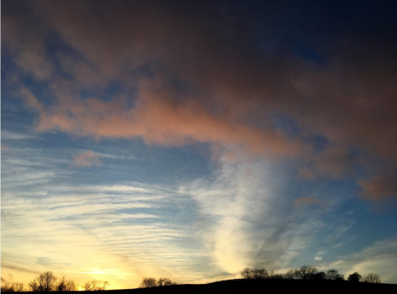

Finds Processing Evening – November 2018

John Russell summarises the DAG finds processing evening…
On a cold, dank November evening 18 volunteers arrived at the Upper Deverills’ Village Hall to process pottery finds from the August excavation at Brixton Deverill. The contrast between the gloom outside and the atmosphere inside the hall – fortified with sponge cake and tea – could not have been more stark. The evening started with the DAG Chairman, David Croot, giving an update on the August dig and we were very interested to hear of some early analysis of the ‘wet’ trench, which is already yielding information about the plant life and human activity for a range of dates that is believed to be unique in the chalklands of SW England. This is very exciting. David then brought us down to earth by reminding us why we were in the hall and gave us our orders for the evening – to complete the marking of Brixton finds and logging them by quantity and weight.
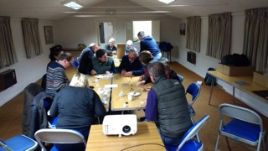
Under the expert guidance of Dr Jörn Schuster, we all set to and armed with nail varnish, dip pens and white ink the finds were marked and processed in very short order. Such was the speed of work, several sticks of shortbread and a piece of sponge cake were also marked and had to be rescued from the finds bags. The evening made an excellent contribution to the Brixton excavation and made us all look forward to the next stages of the project. Our thanks to David Croot and Kevin McBride for setting up the evening and to Lou for providing the delicious and sustaining cake and tea!
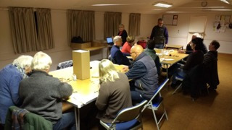
Blog post by John Russell. Images by Jörn Schuster.

November 2018 – Visit to Low Ham Roman Villa Excavation, Somerset

David Croot guides us through the Low Ham Villa excavation open day…
A small number of DAG members joined a surprisingly large group of very intrepid visitors to the Low Ham site in Somerset on 27th November. The weather could not have been worse! After months of good weather the wind blew and the rain poured down throughout the afternoon! Despite this, the Low Ham History Hut was so packed with visitors that the group had to be split into two: half went down to see the three new trenches and the rest stayed in the warm and dry to listen to an illustrated talk on the history of excavations at the site by Roger Leech. The two halves swopped over after 45 minutes and those of us who had enjoyed the warmth and talk ventured out into the torrential rain! Despite the weather we enjoyed a tour of the three new “trenches” (more like open areas!) led by David Roberts of Historic England. Unfortunately for David the skies opened at the final trench and we had to call a halt to the tour. All in all, a fascinating insight to a large scale excavation. Many thanks to David and the crew at Low Ham for arranging this and seeing it through despite the weather!
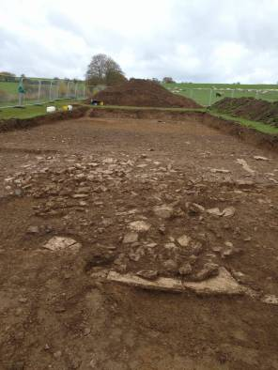
Blog post by David Croot. Images by David Roberts.

DAG inaugural public lecture by Professor Simon Esmonde Cleary - 16 January 2019
John Russell provides a lively overview of DAG’s inaugural talk on Late Roman Britain…
There might not have been much confidence in the Government today but there was shedloads in Kingston Deverill village hall where 70 of us listened spellbound to Professor Simon Esmonde Cleary’s talk on the end of Roman Britain, and whether it ended with a bang or was business as usual for most of the inhabitants most of the time.
Our Chair, David Croot, opened the evening by whetting appetites with a list of the Deverills Archaeology Project’s up-and-coming events over the next few months, which included: geophysical surveying at the end of January, talks by David Roberts and Mike Allen in February and March respectively, and an excavation of an area of the cricket ground in May. While the hall probably sits at the unflashy end of the village hall scale, his announcement that the loos were behind the projector screen would still have come as something of surprise to those for whom it was a first visit. Once this had been clarified, he then introduced the professor and we settled down to hear for the next hour a fascinating yet amusing resume of the facts as they are known.
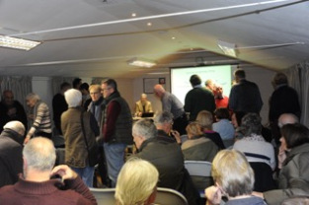
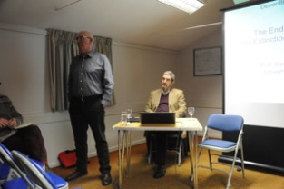
Left: Chair David Croot and Professor Simon Cleary. Top right: The crowd gathers for DAG’s inaugural lecture. Bottom right: David introduces Simon.
Professor Simon started by putting up slides showing perceived views of the end of Roman Britain: eg pre-Raphaelite painting of inconsolable Roman soldier saying goodbye to British sweetheart before dashing off to a dinghy and sailing off to Gaul from what looked suspiciously like Lulworth Cove; arrival on a beach of trendily bearded Vikingesque warriors; and the sack of Rome with lots of scantily clad Roman ladies lying around the forum awaiting their fate (wouldn’t hob-nailed boots and layers of sensible tweed been more sensible in the circumstances?).
He then went on to describe the likely happenings that led to the end of Roman Britain in around AD 410 (I liked the non-PC use of AD rather than CE!). His premise was that up until 400 or so Roman Britain was functioning pretty well and the archaeological record supports this with coins, flashy villas, military garrisons and so forth. However, with the sack of Rome by the Goths and their fellow travellers, Rome lost its ability to govern this far-flung part of the empire, and in any case there were big problems close to home. Constantine III’s disappearance to the continent with a large part of the British-based army didn’t help and things began to crumble. The record shows that there was a huge decrease in coinage, which probably meant that what was left of the Army and civil servants weren’t being paid (sounds a bit like the federal government shutdown in the USA at the moment). Excavations at Birdoswald fort and Chedworth villa show that sites and buildings were taken over by the far less privileged, with hearths set up on the sitting room mosaics and timber buildings erected where stone ones had previously existed. Simon also showed us a spectacular slide which showed the number of rooms occupied in private buildings and the rapid decline in the 5th Century. How on earth that was calculated I will never know but full marks to whoever worked it out. Hoards have also been found. These appear to have been the 5th Century equivalent of putting your cash in an offshore tax haven except it was not the taxman who was after it but a bloke with an unpleasant beard and a very big knife. Simon concluded this part by telling us that there was probably a mass extinction of the landed Romano-British gentry over one or two generations but that the timescale is difficult to determine as coinage disappears from the record.
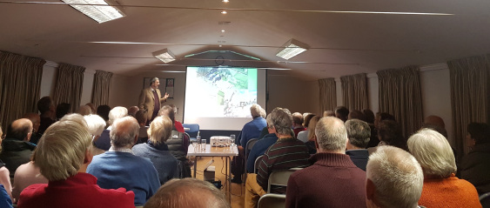
Above: Professor Cleary delivers his lecture
However, the gentry only represented 10% of the population and he believed that for the remaining 90% life continued pretty well as normal. For most of the 90%, life centred around hoping against hope that your parsnip crop would see you through to the next year. No Domino’s in those days if you were feeling a bit peckish. Unsurprisingly the archaeological record for the 90% is pretty thin, not helped by the fact that because it is not very sexy, archaeologists prefer instead to excavate ritzy sites packed with coins, mosaics, pottery, foundations etc. Fortunately, the absence of deep ploughing on Salisbury Plain has preserved some of these sites and Professor Simon showed us air photos of field systems and humble settlements on the Plain. Interestingly, pollen analysis shows that there was little difference between the Roman and early medieval periods, reinforcing the view that for the 90% life plodded on as normal.
Professor Simon concluded his talk by saying how important it is for us to have understanding of how life was for the 90% not just the 10% and that is why the Deverills Archaeology Project has such an important role to play as it looks at what most of the people were doing most of the time. For those involved in the project this was an inspiring message and one that underpins our work. He then very thoroughly fielded a number of questions, which ranged from the ethnicity of those in Roman Britain, what happened to the stone from their buildings, and the location of mints (not the Trebor extra strong type).
Our first talk was a resounding success and we were very privileged to have such an eminent speaker, to whom we are extremely grateful. As the audience was not just made up of those who are actively involved in the project but included many others, we will also have achieved some very useful wider, community engagement.
Blog by John Russell. Pictures by Mike Stanley and Denise Wilding.

Geophysical surveying in January is not for the faint hearted (brrrr… it’s cold) – 25 – 31 March 2019

Claire Watts provides an update on the chilly geophysical survey work undertaken by some very dedicated DAG members!
The week was spent on a site close to the ford in Kingston Deverill. The area on the other side of the ford was surveyed last year with spectacular results and our site had had many PAS (Portable Antiquities Scheme) finds in the past, so there was much anticipation of a great discovery at our fingertips.
Arming ourselves with flasks of hot drinks and dressed in multiple layers topped off with hats and gloves, over the ford we walked and through the gate into our field. I say field, but it felt like we had a whole county to survey, it was SO big and there were only 6 of us with some canes, pegs, tape measures etc. However, the ace up our sleeves of course was the presence of Paul, our professional “geophyser”, who had agreed to guide this bunch of enthusiastic amateurs.
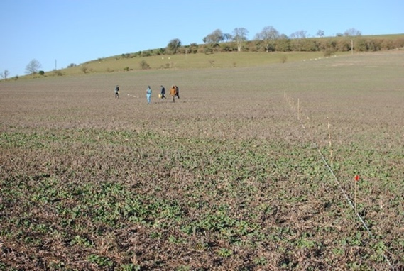
Above: A small section of our field (at the start of the week)
The first task was to mark out accurate grids across the field. This sounds easier than it is in practice. Without a giant set square to hand and after a few false starts we resorted to our O-level maths and Pythagoras’ theory came to the rescue. So, having worked out the tricky matter of right angles we were off and there was no stopping us.
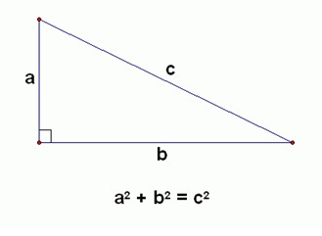
Above: Pythagoras theory was used to mark out accurate grids.
My old Maths teacher at Queen Anne Grammar School, York would have been very proud of me!
With the team now on a roll Paul was able to start the magnetometry. This is quite a speedy job which involved walking up and down the grids that have been set out.
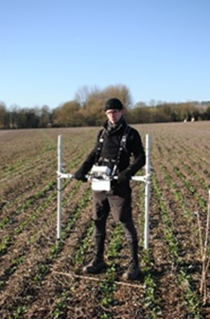
Above: Paul demonstrates how to use the Magnetometer
It was soon time to get the big beast out – the resistance meter. Unlike the mag (speedy work- the hare) the res makes slow progress (the tortoise). You move forward just a metre at a time, plant the machine in the ground and wait for a double beep. We discovered that if you rush or try to have meaningful conversations the machine throws a wobbly. So dedicated concentration is the name of the game. Now, you’ve seen a photo of part of the field so you might be able to understand the scale of the task we faced. We knew we wouldn’t be able to cover the whole area, but we’d do as much as we could and if our dreams that week were to be punctuated with double beeps then so be it.
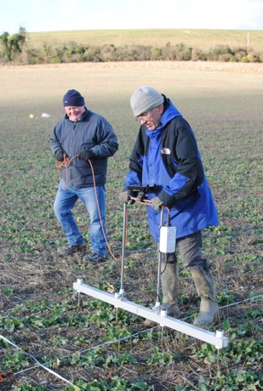
Above: Patience grasshopper – volunteers get to grips with the resistance meter
Thus, we continued all week until ….
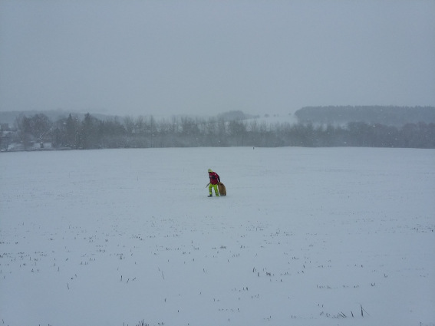
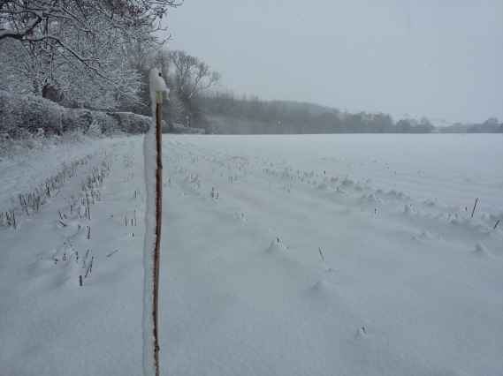
Above: Our field at the end of the week
All we could do was retrieve our canes and pegs, warm ourselves up and await the results of all our hard work. Villa? Henge? Who knows, but we’ve got our fingers crossed that the hare and the tortoise will reveal something amazing between them.
Blog post by Claire Watts. Photos by John Russell and Paul Durdin.

DAG’s second public lecture: ‘South-West Wiltshire in the Roman period – Farming, Pagans and Wealth’ given by Dr David Roberts - 5 February 2019

DAG’s second talk in its winter lecture series was given by the Deverill Archaeology Project’s director Dr David Roberts. John Russell takes us through the events of the evening.
Last night was the second in our series of Deverills Archaeology Group lectures and it was delivered by our very own Dr David Roberts from Historic England. The audience was north of 30, not bad considering it was a disgusting night and there was a re-run of It Ain’t Half Hot Mum on the telly. Before taking the stand he mentioned that he had only just made it back from the Cairngorms. This was most impressive news and there was a gasp of astonishment at the sheer professionalism of the man and his dedication at conducting archaeology in February, in Scotland and at 1200m. A vision emerged of David in a Force 9 gale with beard covered in frost, knee-deep in mud and ptarmigans, busily excavating a Pictish midden or some such. A vision entirely in line with what we have come to expect from him. It was therefore with some disappointment that we heard him go on to say he had been on a stag weekend in Glenlivet. From this early low point the evening could only get better – and get better it most certainly did.
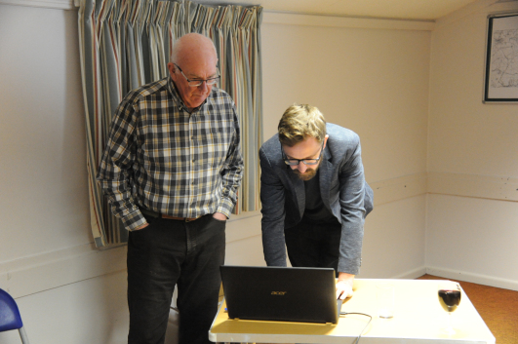
DAG Chair David Croot and speaker David Roberts prepare for the talk

The title of David’s talk was ‘South West Wiltshire in the Roman period – Farming, Pagans and Wealth’ and his intention was to provide us with an overview to give a wider context to our villa and what may emerge in the valley. He started with a slide of the conventional view of early Roman Britain with names of British tribes and their areas with a scattering of towns with their Roman names: Verulanium etc. I’m not sure if it was a typo or the author of the slide had a sense of humour but clearly visible on the south coast was a town called ‘Selsey’. That didn’t sound very Roman to me and I would have been only marginally more surprised if the map had marked Bognor or Peacehaven.
Having convincingly debunked the conventional view of a neatly tribal Britain, he then went on to establish his talk’s baseline by describing how things probably were in the First Century. He started by mentioning hill forts and describing how most were unoccupied by the time of the Roman invasion, that they had dominated the trade routes from the south coast and were displays of power. He then spoke about round houses and the very extensive villages of which they formed part. He gave a particularly interesting description of the village in Stockton Wood on Great Ridge, with the size and complexity of the village with its defensive ditches strongly suggesting the availability of large scale labour and an organised society. He then gave a brief resume of the Claudian invasion and the part Vespasian’s 2nd Legion played in it by advancing down the A303. Vespasian was clearly a bit of a star having accomplished his mission on time and within budget. It appears that SW Britain thereafter was pretty secure and didn’t need a continuing military presence – that was reserved for the north…
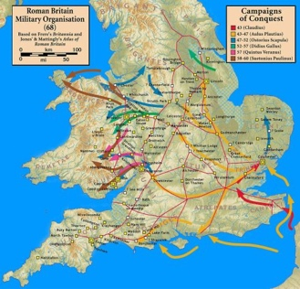
The Roman campaigns in Britain AD 43-60. Source: Wikipedia CC BY-SA 3.0

David then focussed in on Wiltshire, starting by showing a map with roads, towns and villa sites. However, this picture doesn’t show what people actually did, which surely to my mind is the really interesting part of archaeology and a point that David, and indeed Professor Simon in the first talk, returned to a number of times. He structured his description of Wiltshire by using the various sources of evidence, starting with contemporary documentary evidence in the form of the Antonine Itinerary and its mention of Old Sarum (Sorviodunum). This didn’t appear to be a particularly rich seam so he niftily moved on to antiquarian evidence, particularly Nan Kivell’s excavations on Cold Kitchen Hill. Perhaps not alone in the audience, I thought Nan was a woman and I conjured up an image of someone in a tweed skirt and very sensible shoes. However, on checking Wikipedia I discover that Nan was a chap, and a pretty exotic one at that. Anyhow, I digress. Kivell’s excavation produced Samian ware pottery, more than found at the exploratory excavations of the BD villa, suggesting high status activity on the hill.
Next up in the evidence list was aerial photography. While this is efficient at showing what is there, it is expensive because of the large area it covers and doesn’t often help with dating. He showed an interesting slide of crop marks on the Great Ridge before moving on to research projects, using Teffont as the example; a particularly interesting project for us in the Deverills as it is also community-based. This blog is not the place to cover both the fascinating techniques and evidence revealed by the project but we were all intrigued to see how they provide the raw materials for forming a picture of life at the time. The last item on the evidence list was the finds made by detectorists. Their finds are very useful in geographically focusing archaeological effort and David described a temple site in Wiltshire that had subsequently produced a wealth of finds, including curse tablets! Given that some of the tablets referred to the theft of tools, perhaps there is a business opportunity here for those who have had quad bikes and chain saws stolen.
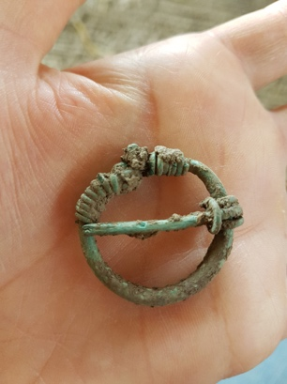
A Roman penannular brooch from Teffont, Wiltshire. Image credit: Teffont Archaeology Project.

David concluded the main part of his talk by describing what he believed the archaeological evidence reveals about Roman Britain in Wiltshire at the time of the Deverill villa, namely: it was a strongly religious society with a mix of paganism and Christianity and rejoicing in large numbers of temples and other religious sites; its economy was based on farming (sheep, grain and cattle) but with significant iron smelting and stone quarrying industries; and there was not much instability.
His finale was to give us an overview of our recent archaeological activity in the valley. He described last August’s dig at Brixton Deverill before giving us a fascinating readout on last week’s geophys at Kingston Deverill. This suggested the possible presence of a henge and a multi-roomed Roman building. How exciting is that!? As only 15% of the field has been surveyed, there is more work to be done…
David packed an immense amount into his 40 minutes and we all departed into the disgusting weather feeling much more knowledgeable about our area and how it might have been. Our sincere thanks to David.
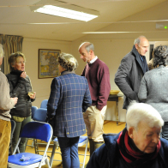
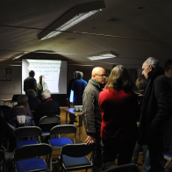
Blog by John Russell. Pictures by Mike Stanley (unless otherwise stated).

DAG’s third public lecture: ‘Prehistory and the changing land-use and environment of the Wylye Valley’ by Dr Mike Allen - 6 March 2019

Denise Payne summarises an informative and enjoyable talk on the environmental archaeology of the Wylye valley.
After a particularly wet and inauspicious day, the evening of the 6th March cleared through sufficiently to ‘winkle’ (hope you got that!) a full house of some 50 DAG members and friends to the village hall for the 3rd of our winter lectures, which was given by Dr Mike Allen of AEA: Allen Environmental Archaeology, based in nearby Codford.
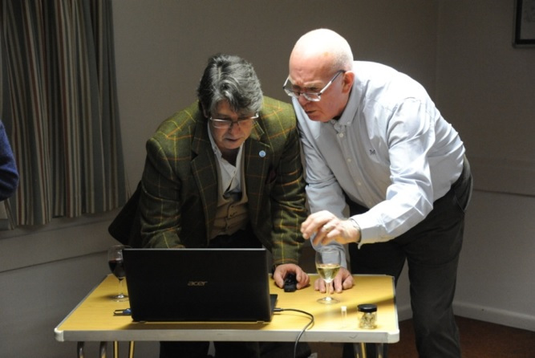
David Croot helps Mike finalise the IT set up.

Entitled ‘Prehistory and the changing land-use and environment of the Wylye Valley’, Mike delivered a very brisk (definitely not snail-paced), illuminating and entertaining talk, illustrated with a very informative selection of slides, graphs and photos showing the prehistoric settlement and burials associated with the Wylye Valley.
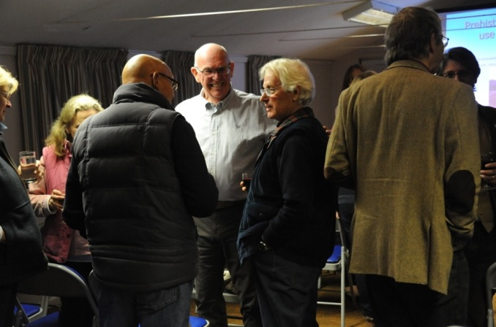
A full house prepares for the talk with a welcome glass of wine

It was particularly interesting to see where these are located in relation to the ancient routeways, many of which we still use today, together with land use and the farming methods utilised over the millennia from Prehistoric times up until the Romans arrived (beyond which Mike considers far too modern) which have changed the environment from ancient woodland to grassland – all aided by his conchology expertise and research. He explained how he obtains samples of snails and processes them in his lab in order to help ascertain the land usage at the time they existed, and he brought a number of examples which were passed round the assembled meeting for all to see, together with a microscope so the members could have a closer look at the specimens.
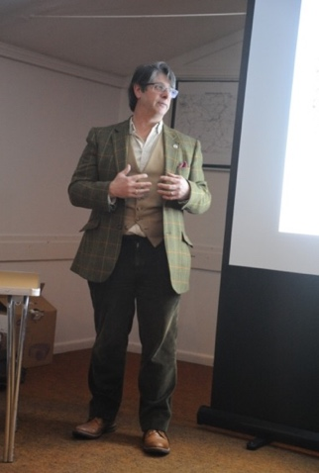
Dr Mike Allen in full flow

In conclusion, Chairman David Croot said that Mike had kindly offered to lead a walk for members to help illustrate the prehistory and changing land usage in our own Deverill Valley – a date has yet to be determined, but watch out for more news in the coming months!
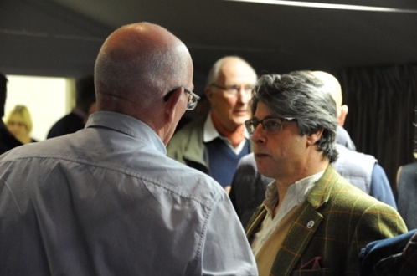
Blog by Denise Payne. Photos by Mike Stanley.

Geophysics Week 25 – 30 March

John Russell recounts an eventful week of geophysical survey, with some unexpected discoveries!
We’ve just completed an excellent – and varied – week of surveying in the Kingston end of the valley. Unlike our last geophys week, this one was completed in marvellous weather.
We started in Church Field, which for a field situated opposite the church is both aptly and cleverly named. The original intention had been to spend most, if not all, of the week in this field but unfortunately it had recently been sown so we were only allowed two days of surveying. With the new timescale in mind, and under the expert guidance of Paul Durdin, we set to with gusto and soon the field was a blur of tape measures, bamboo poles and red pegs, all to the accompaniment of the steady bleep of the magnetometer. By the end of the day three ring features had been revealed by the mag, the largest being some 50m in diameter. The other two were very faint but one had been covered by the res, which showed a ring about 30m in diameter with the high resistance response inside the ring ditch suggesting it could be a barrow. We also made a number of surface finds from field walking, including some Samian ware shards, and parts of quern and wet stones.
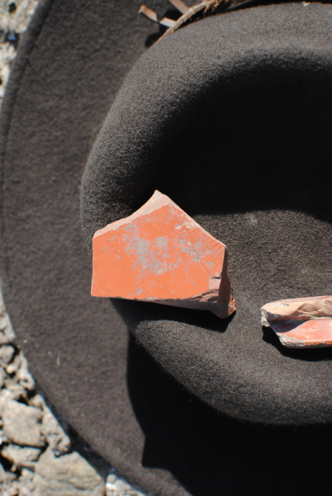
Some Samian wear finds

Soon it was upsticks (well, bamboo poles) and we moved our effort to Seagram’s Field, a dauntingly huge field on the road to Maiden Bradley. Excellent progress was made until agriculture struck again and we were told that the field would be drilled sometime during the day. Keeping firmly in mind that it is farming rather than archaeology that puts food on our tables, we kept going until the tractor and drill were ready to start. Fortunately this wasn’t until the mid-afternoon, by which time we had achieved a solid amount of work.
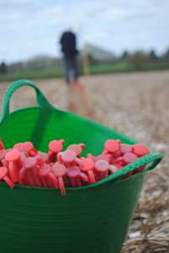
Pegs: A vital component
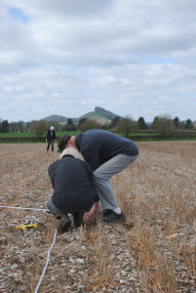
Laying out grids
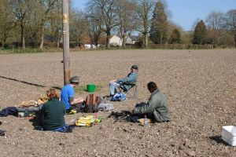
Everyone enjoys a break in the sun
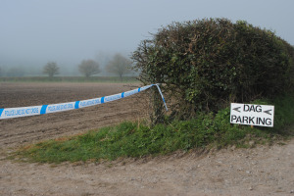
Police tape: Consequences of the munitions find

On the following day surveying continued apace until there was an announcement of a munitions find. Initially this generated huge excitement – was it a ballista bolt in mint condition? Or a hoard of perfect flint arrow heads? Or an Anglo-Saxon sword with gold inlay? Sadly it was none of these but rather a World War 2 2-inch HE mortar bomb, probably dropped by the Deverill’s equivalent to Pte Pike. All the correct procedures were followed and the next day the bomb was detonated by an Army EOD team. Although the field suffered a small dent and we lost half a day of surveying effort, we have the satisfaction of knowing that we have removed a potential threat to the farm staff. At Seagram’s Field our surveying has revealed various linear features scattered across the mag results, possibly parts of enclosures. The clearest feature though was in the southwest part of the field: a sharp rectangular enclosure with a double ditch on its eastern and northern sides. We surveyed this with both mag and res – the latter showed a smaller internal enclosure, along with suggestions of other features. The form of the rectangular enclosure suggests it is Roman. Surface finds in this field were few and far between: a few pottery shards and some small pieces of worked flint.
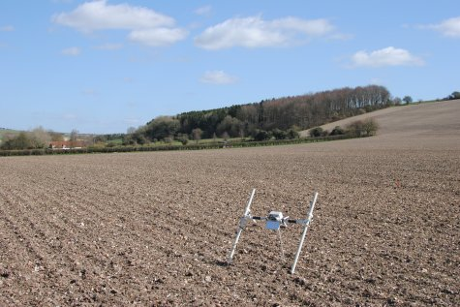
The Magnetometer

Although we didn’t conduct the surveying we intended, this was a successful week greatly helped by the wonderful weather. Our thanks to Paul for his patience and guidance, to David Stratton for allowing access to fields for survey, and well done in particular to Adrian and Matthew for their work with the mag.
Blog by John Russell.

DAG session with Warminster Brownies
David Croot, Lorraine and Lou responded to an invitation from Brown Owl to help 15 of her 7th Warminster Brownies pack to achieve their Archaeology Badge. The Archaeology Badge is a new badge for the Brownies and this pack will be the first in the area to work towards it. The trio were met by 15 very excited but well behaved Brownies, all aged between 7 and 10 at their community-centre home. We were welcomed with a special Brownie Hello and following this, David started the evening by giving a fun PowerPoint presentation which was geared towards the age group on how to achieve their badges.
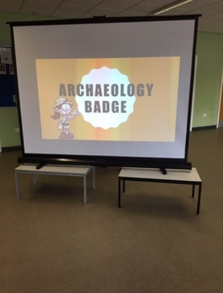

The presentation given by David to help the Brownies gain their archaeology badge.
The presentation was followed with a session “digging” for buried finds (including coins, jewellery (borrowed from Lorraine), bones and pottery) in sand trays, identifying the items and giving them some kind of interpretation. There was a lot of discussion about the items that they had found (especially the shiny coins and jewelry)!
Lou had also brought along some of the pots her dad had found whilst in the fields working with the tractor. The afternoon was very well received by the pack who were really engaged and were full of questions about archaeology. We thoroughly enjoyed the session too and hopefully other groups will ask for a similar event. Many of the brownies will be visiting the Kingston Deverill dig in June as part of their archaeology badge activities and we look forward to seeing them!
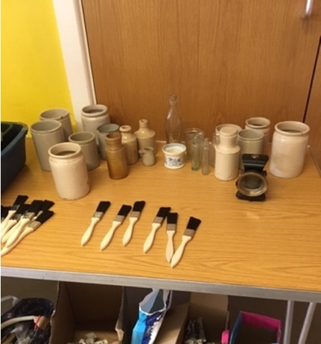
Artefacts for the Brownies to examine, including pottery and bottles.
Blog and photos by David, Lorraine and Lou.

June 2019 excavation dig diary
Day 1
In warm sunshine, we unloaded kit from Historic England’s Land-Rover, stowing every mattock and finds-tray in the village hall on an immense tarpaulin kindly loaned by DAG volunteer Sarah. In the corner of the field where we’re excavating, nettles stood as high as a proverbial elephant’s eye: fortunately, the tracks on Richard’s Kubota excavator can flatten anything, so no need for Chairman David to fetch his brush-cutter.
Richard had barely scraped off a single length of turf when animal bones and sherds of pottery began to appear: could we be on the right track, as geophys results had strongly suggested? Once the Kubota was swinging its digging-bucket further up-slope, hard-hatted volunteers scampered onto the area already scraped, cleaning back the surface, and straightening its edges as far as crumbly top-soil would allow. Operations were closely supervised by Richard’s terrier, perched in the cab’s doorway.
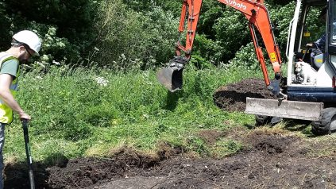
‘Historic’ David and the machine

Day 2
Flaming June? What a joke!! Cold, torrential rain overnight and all morning followed by heavy downpours in the afternoon. Needless to say we cancelled all activities for the day on the basis of the weather forecast. I wonder if we will be excavating two swimming pools tomorrow!!?
Some may ask why the Deverill valley is so keen to keep its archaeological secrets (snow, unexploded ordnance, and now heavy rain in June!).
Soon finds were mounting up in a tray, smartly context-numbered, and a lovely clear chalky surface lay before us: this is the cue for much peering and speculating about whether any clues as to possible features are yet revealed.
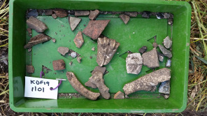
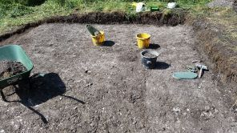

Meanwhile Richard was scraping off the surface for our second trench, a bit nearer to the village hall. This caused Historic David (not to be confused with Chairman David) to become slightly excited and wave his arms: “Look! Here is clay – here is a bank – here is one edge of a ditch …” The Kubota scrapes a bit more. “And here is the other edge of the ditch!” The word “possibly” was in there somewhere. Several pairs of hands were moved into the new area to define the possible bank and generally clean back, in the process gleaning another tray of finds, including part of a vessel’s base – could be Black Burnished Ware, local Dorset pots that the Romans used in industrial quantities all the way from Poole to Hadrian’s Wall; “and the obligatory oyster shell” commented a neighbour from down the valley who had dropped by (having Roman remains in his own back garden, he’s seen a few oyster shells dug up).
As shadows lengthen, it is time for the ancient ritual ceremony of Unrolling The Orange Plastic Mesh; and so ends day 1. “We have one day more than they have on Time Team” says one of the Davids. But what does the weather have in store? Tune in again for episode two.

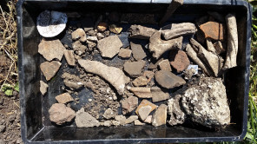
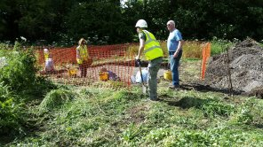
(Blog and images by Matthew Tagney)

Day 3
Ed and I finished removing the fill from part of the linear ditch in Trench 2 where yesterday we had found a couple of lovely glazed Medieval pottery sherds. We then completed our context sheets (oh joy), including using the Munsell chart to determine the colour of our ditch fill. Soooo many brownish hues to choose from!
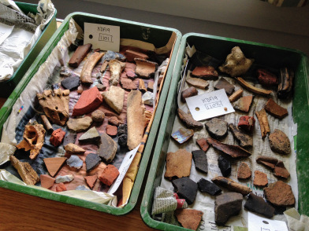
Our finds from Trench 2

The heavy rain held off until afternoon tea break (see, David Roberts is not such a slave driver). Good timing and today we were treated to brownies of a different kind, thanks to David and Lorraine’s daughter, which were delicious.
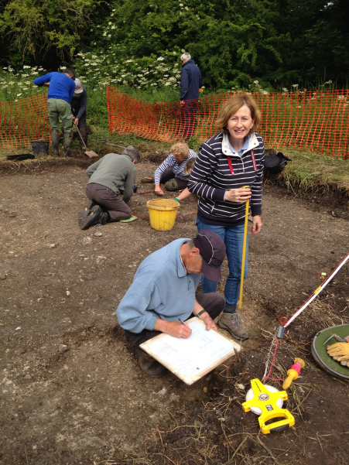
Drawing a section

At the end of each day’s digging, David asks for a ‘willing’ volunteer from each of the trenches to explain what has been happening in their trench that day. Luckily for me, I got this out of the way early on and did my turn yesterday, so I could relax! It is a great idea though to ask us diggers to give the trench tours as it encourages us to keep tabs on what is happening in our trench. There are always opportunities to discuss ideas with fellow diggers and the management! Our supervisors, Mike and Jonathan, together with David, are all good at asking us questions about the features we are digging and giving clear explanations as to their reasonings if they disagree with us!
It was another good day on site and I’m looking forward to finding something Roman tomorrow, hopefully…
Day 4
After a morning of clearing trenches 1 and 2, we welcomed the 7th Warminster Brownie Pack on site. The Brownies’ visit followed on from a presentation David Croot gave to the pack in May, assisted by Lorraine and Lou.
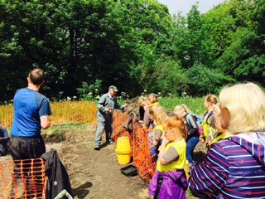
The Brownies get a first view of the excavation.

The Brownies started with a guided tour of the two trenches given by our own real-life archaeologist, Dr David Roberts. This was followed by an opportunity for the Brownies to have a go at digging for themselves. Although they were unable to dig in the trenches, they had great fun digging in the spoil heap, once Rod had demonstrated that you really can find hidden treasure in the disregarded spoil! The Brownies had a great time and soon began to be able to tell pottery and bone from flint and stone, with one Brownie even finding a wonderful piece of pottery with a thumb-print pattern below the rim.
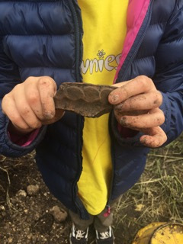
Great find!

Once they had gathered their finds, they took them to Ted and Denise where they were shown the techniques of cleaning finds and even had the opportunity to have a go themselves.
With the assistance of DAG, the Brownies now have enough experience and evidence to allow them to earn the Archaeology Badge, a new badge and the 7th Warminster Brownies will be the first pack in Wiltshire to earn it!

Day 5
Following Sunday’s dreadful weather, Monday started quite kindly! This would be our final day of activity, so the teams cracked on with small extra excavations in some key parts of the two pits whilst the post-ex team processed the outstanding finds that had dried overnight. There were a few new finds from the morning’s work, and a few trays’ worth of finds from Saturday and Sunday that hadn’t quite dried were left for onward transport, drying and processing in David’s garage!
By lunchtime the anticipated rain arrived on cue, along with 13 schoolchildren from Crockerton Primary school and their teacher and 2 parents. Denise Wilding gave a talk with a Powerpoint presentation on archaeology, supported by the two Davids, and after this the children paid a brief visit to the active excavations at the bottom of the cricket field. As the rain got heavier the whole party retreated to the village hall where Lou, Lorraine, Denise and David had prepared some sand trays with hidden ‘finds’ for them to discover.
Long discussions followed about the significance and interpretation of animal bones, teeth, pottery and coins. Of course we could not ignore the fact that the children’s school is located on Potters Hill, in a place called CROCK er TON (the place where pots were made). Were any of the pot sherds we have found made in Crockerton? Not a question we could answer! The children thoroughly enjoyed their visit and who knows, maybe some future archaeologists were amongst them!
The day was wrapped up by the teams finalizing the recording of the trenches and logging all the finds that have been processed to date and bagging the weighed finds. The last job was to thoroughly clean the village hall and load the kit into the HE Landrover.
Tuesday would see the pits back-filled and the site tidied up by Chris the digger driver.
(Blog by David Croot, Sophie Hawke, Louise and Lorraine) (Images by Jane Hanbridge)

Finds Processing – July 2019
Five of us gathered on 1 July in Upper Deverill’s village hall to mark the finds from the June excavation of the north-east corner of the cricket pitch. This was a pretty quick affair as the excavation had not produced large quantities of finds; in fact the number of bags of finds was only just greater than the number of volunteers! A vast improvement since the last marking session was our use of permanent Lumocolours instead of scratchy dip pens and nail varnish. Many thanks from the volunteers for the sustaining tea and eats!
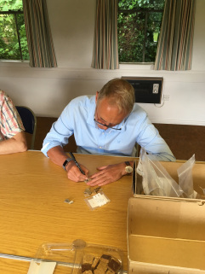
Bag KDF 19 1101 taking its place in history

Dem bones, dem bones…14 August 2019

Zooarchaeology training
On Wednesday nine of us gathered at Home Farm, Teffont Evias for an afternoon of animal bone study led by one of the world’s rarities, a freelance zooarchaeologist. Clare Rainsford generously gave her time and expertise to DAG to throw some light on this fascinating subject and Home Farm kindly allowed us to use their office space as the weather was dreadful and the barn reserved for the study was far too inhospitable for us less-seasoned archaeologists.
So what did we learn? First up we learned that zooarchaeology is the study of the relationship between archaeological bone finds and ancient peoples. Clare then chucked us in the bony version of the deep-end by setting us the challenging task of assembling a cat and a sheep skeleton from what appeared to be bags of random bones. We approached the task with lots of enthusiasm but less skill, with the sheep group being particularly flummoxed by the hind leg differences between sheep and man. By studying the difference in skeletons we were taught to distinguish between bird and mammal, the predator and the prey, the herbivore and the carnivore, the cloven-hooved and the single-hooved or ungulate. We learned how to identify horse and cow teeth from the patterns in the chewing surface, although there were varying degrees of conviction over the similarity of patterns to butterflies and snoopy dogs!
Importantly, we gained some understanding into how the socioeconomic status of a past society can be determined to some extent through animal bone finds. For example, deer bones found in an urban environment could suggest that the animals had been brought from their natural habitat for sport or food, a possible sign of economic prosperity.
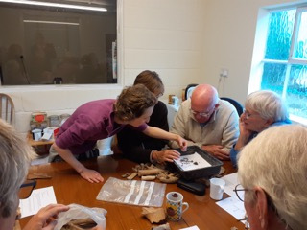
DAG Chair David Croot getting to grips with the difference between a horse’s hoof and a chicken wishbone.

The afternoon was very informative and enjoyable and we left Teffont Evias considerably more knowledgeable about animal bones than when we arrived.
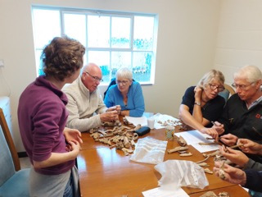
The knee bone’s connected to the thigh bone…
Our sincere thanks to Clare for putting over this complex subject in such an entertaining and understandable way and the next time we are on an excavation we will be better equipped to identify the bones we dig up.
Blog by Eve and photos by Sophie.

Results’ Workshop − 16 August 2019
Forty-three of us gathered in the village hall on the evening of 16th August to hear three fascinating talks summarising the results of the Deverills’ Archaeology Project (DAP) over the last 18 months. This size of audience was a pretty good effort as the weather was horrendous. Given the amount of water being dumped on us perhaps it would have been more fitting to have heard a lecture on maritime archaeology.
David Croot introduced the results session and the speakers and made particular mention of the organisations that had made the project possible financially: the Heritage Lottery Fund, the Warminster Area Board and the village hall.
Dr David Roberts then gave a very comprehensive overview of the project’s achievements, which have been impressive: six geo surveys, three talks, two excavations, funding wins, public engagement and, most important of all, significant gains in our
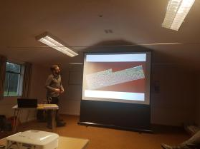
Fortified by two glasses of wine, David Roberts talks us through the ring barrow.
historical knowledge of the valley. He then went into more detail on the three surveys, showing us slides overlaying the results on mapping and explaining (or surmising on) the various features that were evident. Some of the features, such as the ring ditch (or is it a henge?) in Church Field, were very striking and are pointers as to where we may concentrate our work in the future. David then described the two excavations and his first thoughts on the results. The Brixton dig in 2018 not only provided many of us with our first experience of archaeological excavation techniques but has revealed some form of enclosure, possibly for animals, which is probably contemporaneous with the villa. However, the most interesting results are yet to emerge – the analysis of the samples taken from the dark, waterlogged context in Trench C. This analysis will soon be undertaken by Mike Allen.
While David drew breath, Dr Claire Rainsford stepped in to give us a summary of the early analysis of bones recovered during the excavations. While the samples were small, they seem to show that in the Roman and medieval period people enjoyed roast beef whereas in the post-medieval period roast lamb (or perhaps shepherd’s pie) was favourite. We also enjoyed a diversion into experimental archaeology, which revealed how it was discovered why fish bones don’t tend to appear in the archaeological record (detail of the experiment redacted to spare the squeamish).
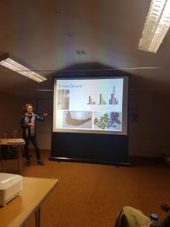
Claire Rainsford describing our bones’ finds.

David then took the floor again to describe this year’s Kingston dig. While relatively little was found, the excavation has given us a better understanding of the ground adjacent to the ford and showed that although Roman pottery was found, the area was mainly in use in the medieval period as some form of working platform. David concluded by showing us the map of known finds in the valley and then pointing to where our work had increased the sum of knowledge. In the short period of the DAP’s existence this was quite impressive, not only giving us a warm glow that our work to date had been very worthwhile but also an inspiration for our future work. David then introduced Dr Jörn Schuster, our small finds expert, who gave us an overview by way of a statistical analysis by type and quantity of the small finds we have made. Given the small quantities, it was difficult to produce dramatic conclusions but it was interesting to learn about nails and buckles various. The most impressive find was a large key and one can imagine the conversation that followed its loss centuries ago, which probably went along the following lines, “What do you mean you’ve lost our only key to the manor house front door? It’s massive, you couldn’t have lost it! Alright, if you really can’t find it, saddle the donkey and get yourself to Cordens and get a new one made. See you in 5 days.”
There then followed a wide ranging Q&A session after which David Croot thanked the speakers for their talks and for all their work to support the DAP, which generated warm applause. An excellent evening and one which has given us a solid foundation for next year’s work.
Blog by John. Photos by Denise.

Flotation…but not as you know it! – 26-30 August 2019
When we undertook the excavation in Brixton Deverill in 2018 we discovered and carefully mapped and sectioned key Roman and later features, including a deep trench which contained waterlogged horizons/contexts at its base and what our professional advisers believed to be a gravel platform for some kind of processing. Samples – including snails, pollen, wood, charcoal etc – of each context were taken for further work on specific environmental indicators.
We are amazingly lucky to have on our doorstep in Codford Dr Mike Allen, who owns and runs one of only two privately owned environmental archaeology laboratories in the country. We are also hugely fortunate that he is so keen to support groups like ours and with his abounding energy and enthusiasm help us develop our environmental archaeology skills. So, after some to-ing and fro-ing matching volunteers with Mike’s availability, we settled on the last week in August as our processing period, which as a best guess would be 5 days for 3 volunteers. We were blessed with unusually good weather for the processing, which was lucky since most of the work takes place outside! Sat in the sun around one of Mike’s outdoor seating/BBQ spots, we began with a morning’s introduction to the tasks ahead. He introduced us to the principles of sample preparation by flotation, which has a number of stages: soaking the samples; large tank primary flotation (outside); laboratory based second flotation; separation/fractionation of residue by wet sieving; drying and sorting of residue; examination and assessment of the flots collected by flotation. All the while accurate labelling of EVERYTHING is essential!
Prior to work beginning, several of the samples had been subdivided into 10-litre sub-samples and, in readiness for flotation, pre-soaked in large plastic wine/beer fermentation tubs with a quantity of hydrogen peroxide to break up aggregates.
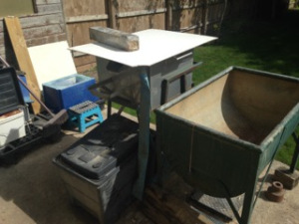
The primary flotation tank (Ed. I think it’s the one in the middle!)

The first stage of processing takes place using a large stainless steel flotation tank into which the sample ‘soup’ is poured. Water is drawn by a submersible pump from a lower reservoir and forced through a series of tubes within the flotation tank, which have holes in them thus creating a constant flow of agitated water. As the tank fills, the water flows over the lip of a weir and into a fine mesh (300 micron or 0.3mm) sieve. Anything which floats over the weir (eg charcoal, wood, shell fragments, plant fibres, grains and husks) is therefore collected as flots in the sieve and the water drops into the reservoir tank and is re-circulated. The mesh size allows suspended sediment (clays and silts) to pass through. To help the process the operator gently agitates the sediment ‘soup’ by hand, hopefully releasing any flots that may be held down by heavier muck clinging to them. Samples took anywhere from 1 to 3 hours to process (fine in great weather but can’t be much fun in cold and rain!). We quickly learned that opening the water flow valve too much leads to a torrent flooding the sieve and the loss of important flots! Once we (Mike) was satisfied that no more flots were likely, we carefully removed the mesh basket liner and decanted the residue into a bucket for the processing second stage. Meanwhile the flots were set to dry on their labelled sieve. Ready for the next sample!
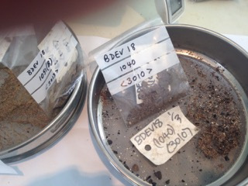
Flots caught on the 300micron sieve: charcoal, shell fragments, plant remains.

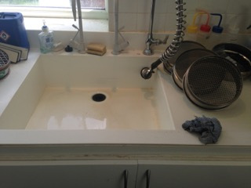
Secondary flotation in the lab sink.

Mike explained the importance of second stage flotation as many flots are missed in Stage 1. Stage 2 involved working in the lab at a large purpose-built sink. The residual sample (minus its flots from Stage 1 and some of the very fine sediments that went down the waste gate) was now placed in a 5 litre bucket of water. After swirling the sample around with a large spoon or by hand, the liquid was carefully and slowly decanted through a 500 micron sieve; the bucket was then refilled and the procedure repeated until no further flots appeared. The sample was now ready for wet-fractioning through a small nest of sieves, while the flots retained on the sieve were dried for examination and assessment, along with the flots from the primary flotation. Fractioning the remainder of the sample proved tricky, particularly where there was a large proportion of peaty plant remains that clogged up the finest mesh sieve at the bottom of the stack. These samples required heaps of patience as it was very tempting to tip too much sample into the top of the stack, only to find that the bottom sieve was overwhelmed! Eventually there were two sets of flots, material caught on each sieve and a lot of water and silt/clay that had gone down the drain!
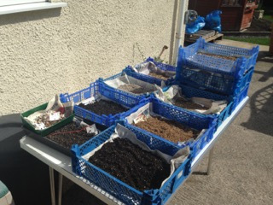
Sieve fractions drying in the August sun

Each sieve fraction was now laid out in the sun on a drying tray on newspaper to thoroughly dry. Once dry (anywhere between an hour and two days), the fractions would be examined for any artefacts (which are bagged and labelled individually), and then weighed and the weights recorded on the master chart. The coarsest fractions are discarded and the rest bagged, labelled and stored. Simples, and that’s the story of one 10 litre sample: only another 170 litres to go!
Once the flots have dried they will be assessed by Mike and he will decide whether they have sufficient merit to pass them on to specialists in grain and husk, wood/charcoal etc identification. He will of course do any work on snails himself!
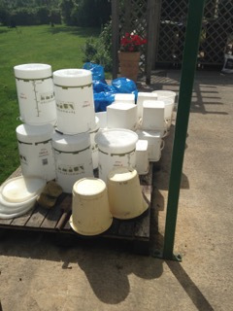
Cleaning up is important too: and no, we didn’t brew wine or beer!

It wasn’t all work! We had some great conversations over coffee and lunch with Mike and his wife about all manner of things from families to gardening and of course archaeology.
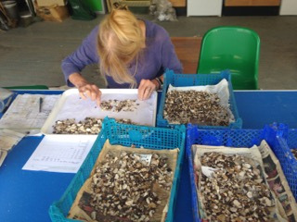
Sorting and carefully examining each dried fraction for anything apart from natural stones!

This was a very interesting week and we were exceptionally well looked after and trained by Mike, to whom we are very grateful.
Blog by David Croot

Talk to Crockerton and Deverill Valley WI – 11 November 2019
DAG were delighted to be invited to talk to one of our local WI groups in November. Our chair, David Croot, was warmly welcomed by Sue Bohanna (she of Warminster Brownies fame!), who not only eulogised about DAG’s support for the Brownies, who are the first Brownie group in Wiltshire to gain their ‘Archaeology Badges’, but also explained that one of the Brownie fathers who came along to the dig in Kingston Deverill with his daughter was so impressed with the kind of activity that the Brownies get up to, that he enrolled as the very first male Brownie leader in Wiltshire!
The introductions over with, David tried to live up to the billing. He gave an illustrated talk to the group of 15 WI ladies covering DAG’s discoveries over the past two years with the support of the Historic England professional team and the financial support of the Heritage Lottery Fund. The group seemed very impressed with our achievements and there were several insightful questions arising from the talk.
All in all, a successful evening, and we look forward to offering similar talks in the future to local groups.
David Croot

Talk on archaeological surveying – 20 February 2020
David Sabin, of Archaeological Surveys Ltd gave a talk to a packed Upper Deverills Village Hall on Thursday February 20^{th,} and it was hugely encouraging to see so many DAG members, local residents and others turning out on a cold, wet February night! David works with English Heritage and is a specialist geophysical surveyor with over 25 years experience, carrying out over 60 projects a year.
He took his audience on a tour of important archaeological sites throughout Wiltshire in which he and his company have played instrumental investigative roles. He has used a wide range of geophysical techniques and equipment including ground penetrating radar, resistivity and geomagnetism. Each technique has specific uses depending on the ground conditions and what is under investigation.
David’s work is mostly funded by developers who need to establish whether important archaeology may be located in an area where they intend to develop. This is particularly true where sizeable towns such as Swindon are expanding, and lie at the crossroads of important Roman routes. His work has been key to discovering the extent and complexity of Roman settlements to the east of Swindon, and hopefully safeguarding these sites from destructive development.
It was very kind of David to bring along his expensive and well-used magnetometer. This piece of equipment was a German model mounted on wheels which can cover several hectares of ground in a single day!
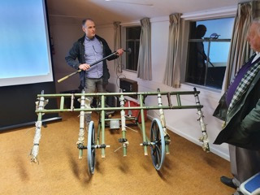
David demonstrating the very latest in mobile bedsteads

A big difference compared with the hand-held resistivity kit we will be taking delivery of in March. When fully trained and competent we might cover a few hundred square metres in a day! No matter, maybe we can save up for a few years……..(Ed. decades?!)
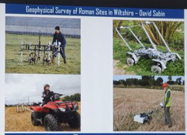
Oh for a few quid!

David rounded off the evening with a summary of the results of his survey of the Deverill Villa, which showed us just how vital geophysical work is when exploring sites for the first time. It is accurate and can be very efficient given the right kit – and expertise.
Inspired by his talk, a few hardy members of DAG are now itching to get their hands on our own resistivity kit at the training on 15 March! (Afternote: This never took place due to the imposition of the government lockdown in response to the Covid-19 pandemic)
Blog by David Croot. Photos by Matthew Tagney

