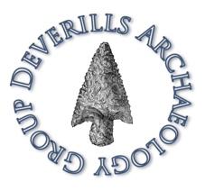
Deverills Archaeology Group

About
The Deverills Archaeology Group (DAG) was formed as a community archaeology group late in 2017 following the discovery of a Roman villa.
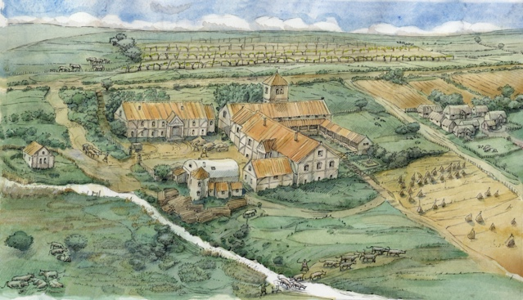
The group aims were to improve understanding of, and engagement with, the archaeology and heritage of the Upper Deverill valley through a range of activities including:
- Co-ordinated archaeological research in the Upper Deverill Valley
- Disseminating the results of that research in an accessible and sustainable manner, (including depositing copies of all reports with the Wiltshire Historic Environment Record, and archives with the relevant collecting museum)
- Providing information on, and opportunities for, training and education in all aspects of theoretical and practical archaeology, through lectures, workshops, events, walks and practical activities
- Encouraging members to work on research and survey projects either as individuals or in teams, on behalf of DAG and to provide members with assistance in planning their projects
- Ensuring that the County Archaeologist, the Wiltshire Archaeological and Natural History Society, the parish council and other relevant bodies are informed of current and future activities.
The DAG had a small committee of volunteers drawn from the local community including a chair, secretary and treasurer who all lived in the Deverill valley or nearby.
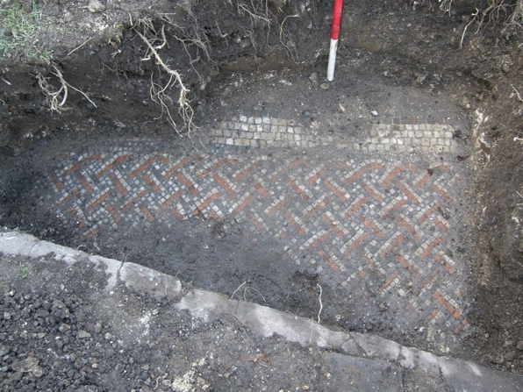
Above: The mosaic from the excavated villa. (C) Wiltshire Archaeology Service
At an Extraordinary General Meeting held on Wednesday 4 November 2020 it was with much regret unanimously agreed to wind-up the DAG as there were no volunteers to take-up the positions of Chairman, Treasurer and Secretary. The final holders of the three posts were: Chairman – David Croft (Brixton Deverill); Treasurer – Kevin McBride (Brixton Deverill); Secretary – John Russell (Warminster).

